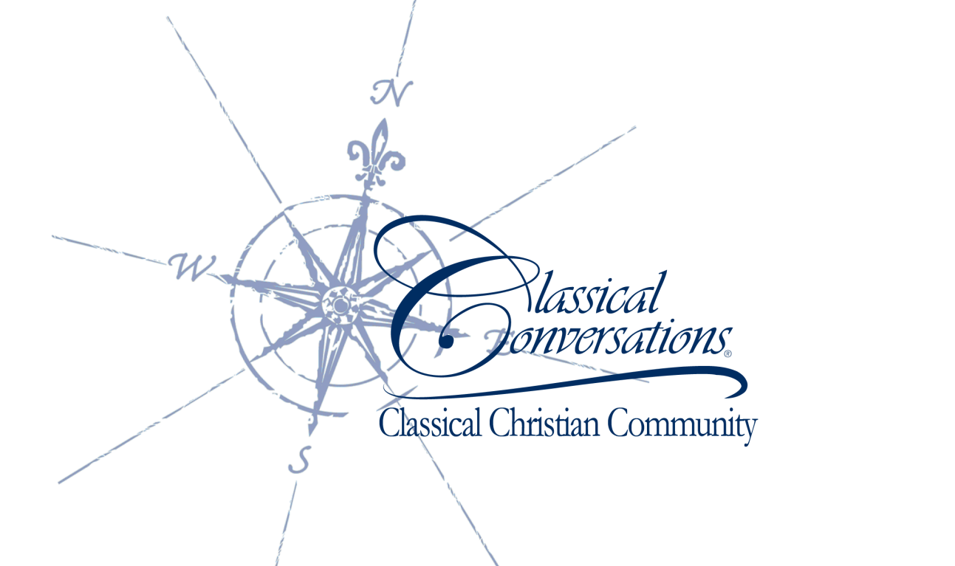

Classical Conversations Information Meetings

NEW Kingwood Campus Location!

(Please RSVP to attend an Info Meeting to cboothe@classicalconversations.com)

Tuesday, June 19th

9am-11am

McDonald’s

2162 Northpark Dr

Monday, June 25th

10am-Noon

McDonald’s-Porter

24610 FM 1314

Thursday, June 28th

2pm-4pm

Octavia Fields (Humble) Library

1503 South Houston Ave.

Friday, June 22nd

2pm-4pm

McDonald’s

4406 Kingwood Drive

Monday, June 25th

1pm-3pm

Atascocita Library

19520 Pinehurst Trail

Saturday, June 30th

9am-11am

Starbucks

4522 Kingwood Dr.

Also, register online for our FREE 3-Day Practicum!

(Academic Kids’ camps available for children of practicum attendees for a nominal fee!)

Come learn about Classical Christian homeschooling through the Middle school and High school years, How do I do this in my home? Why Latin? And much more!

July 19th, 20th, and 21st

9am-4pm

Lakeway Baptist Church

5801 FM 1960 East

Humble, TX 77346

**Please note: Registration Deadline is Thursday, July 5th!

Register online at: [www.classicalconversations.com](http://www.classicalconversations.com)